Results

This study was conducted at Benha University hospital on 120 patients. Patients was randomly assigned into 4 groups as follows:
- Group I: 30 patients received general anaesthesia only.

- Group II: Patients will receive general anesthesia plus ultrasound-guided, modified Pecs block with 30 mL of 0.25% bupivacaine hydrochloride (Markyrene®Sigma-Tec, Egypt).

- Group III: Patients will receive general anesthesia plus ultrasound-guided, modified Pecs block with 30 mL of 0.25%bupivacaine hydrochloride (Markyrene® Sigm Tec, Egypt) plus ketamine hydrochloride (1 mg/kg) (Ketamine®Sigma-Tec, Egypt).

- Group IV: Patients will receive general anesthesia plus ultrasound-guided, modified Pecs block with 30 mL of 0.25% bupivacaine hydrochloride (Markyrene®Sigma-Tec, Egypt) with insertion of catheters 20 G for booster doses of local anesthetic.

- General characteristics in different study groups
- Age
- There was no significant difference between study groups as regard age. P value was 0.163.
- BMI
- There was no significant difference between study groups as regard BMI. P value was0.373
- Duration of surgery
- There was an overall significant difference between study groups as regard duration of surgery. P value was <0.001. Pairwise analysis revealed that:
- Mean duration in group I was significantly higher (74 min) compared to group II (67 min).
- Mean duration in group IV was significantly higher (76 min) compared to group II (67 min).
- Mean duration in group IV was significantly higher (76 min) compared to group III (68 min)
- ASA
- There was an overall significant difference between study groups as regard ASA. P value was <0.001. Pairwise analysis revealed that ASA ingroup IV was significantly different from groups I,II and III. 80% of group IV were ASA II compared to 43.3%, 36.7% and 33.3% in groups I, II and III respectively.
(Table 2& Figure20…)

Table (2 ) General characteristics in different study groups
 |  | Group I  (n = 30) | Group II  (n = 30) | Group III  (n = 30) | Group IV  (n = 30) | P value
Age (years) | Mean ±SD | 46 ±10 | 49 ±6 | 48 ±11 | 50 ±5 | 0.163
BMI | Mean ±SD | 26 ±3 | 25 ±3 | 25 ±3 | 26 ±3 | 0.373
Duration of surgery | Mean ±SD | 74 ±9 | 67 ±9 | 68 ±8 | 76 ±9 | <0.001
ASA score | I n (%) | 17 (56.7) | 19 (63.3) | 20 (66.7) | 6 (20.0) | 0.001
 | II n (%) | 13 (43.3) | 11 (36.7) | 10 (33.3) | 24 (80.0)
One way ANOVA was used for numerical data. Categorical data was compared using Chi-square test
BMI = Body mass index
ASA = American Society of Anesthesiologists

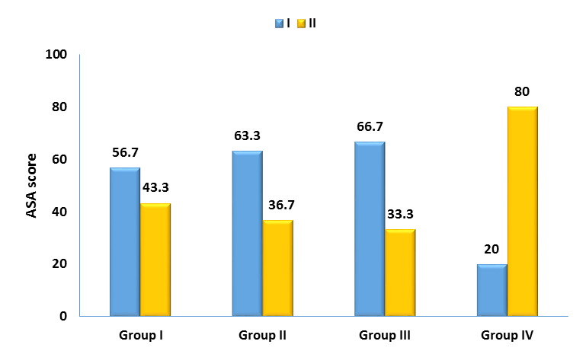

figure (20 ) ASA score in different study groups

- Post-operative heart ratein study groups
- Immediate post op, at 1 hour &at 2 hours
- There was an overall significant difference between study groups. P value =0.003. Pairwise analysis revealed that:
- Mean heart rate in group I was significantly higher (78) compared to group IV (74).
- Mean heart rate in group II was significantly higher (78) compared to group IV (74).
- At 4 hours
- There was an overall significant differencebetween study groups. P value <0.001. Pairwise analysis revealed that:
- Mean heart rate in group I was significantly higher (84) compared to group III (76).
- Mean heart rate in group I was significantly higher (78) compared to group IV (76).
- Mean heart rate in group II was significantly higher (81) compared to group III (76).
- Mean heart rate in group II was significantly higher (81) compared to group IV (76).
- At 6 hours
- There was an overall significant differencebetween study groups. P value = 0.002. Pairwise analysis revealed that:
- Mean heart rate in group I was significantly higher (81) compared to group III (77).
- Mean heart rate in group I was significantly higher (81) compared to group VI (77).
- At 12 hours
- There was an overall significant differencebetween study groups. P value <0.001. Pairwise analysis revealed that:
- Mean heart rate in group I was significantly higher (83) compared to group II (78).
- Mean heart rate in group I was significantly higher (83) compared to group III (77).
- Mean heart rate in group I was significantly higher (83) compared to group IV (74).
- Mean heart rate in group II was significantly higher (78) compared to group IV (74).
- Mean heart rate in group III was significantly higher (77) compared to group IV (74).
- At 24& 48 hours
- There was an overall significant differencebetween study groups. P value <0.001. Pairwise analysis revealed that:
- Mean heart rate in group I was significantly higher (87) compared to group III (80).
- Mean heart rate in group I was significantly higher (87) compared to group IV (76).
- Mean heart rate in group II was significantly higher (84) compared to group IV (76).
- Mean heart rate in group III was significantly higher (80) compared to group IV (76).(Table3& Figur21)

Table ( 3) Post-operative heart rate in different study groups
 |  | Group I  (n = 30) | Group II  (n = 30) | Group III  (n = 30) | Group IV  (n = 30) | P value
Immediate | Mean ±SD | 78 ±4 | 78 ±4 | 75 ±5 | 74 ±5 | 0.003
After 1h | Mean ±SD | 78 ±4 | 78 ±4 | 75 ±5 | 74 ±5 | 0.003
After 2h | Mean ±SD | 78 ±4 | 78 ±4 | 75 ±5 | 74 ±5 | 0.003
After 4h | Mean ±SD | 84 ±8 | 81 ±7 | 76 ±4 | 76 ±4 | <0.001
After 6h | Mean ±SD | 81 ±7 | 80 ±6 | 77 ±4 | 77 ±4 | 0.002
After 12h | Mean ±SD | 83 ±3 | 78 ±4 | 77 ±4 | 74 ±4 | <0.001
After 24h | Mean ±SD | 87 ±4 | 84 ±7 | 80 ±6 | 76 ±5 | <0.001
After 48h | Mean ±SD | 87 ±4 | 84 ±7 | 80 ±6 | 76 ±5 | <0.001
One way ANOVA was used

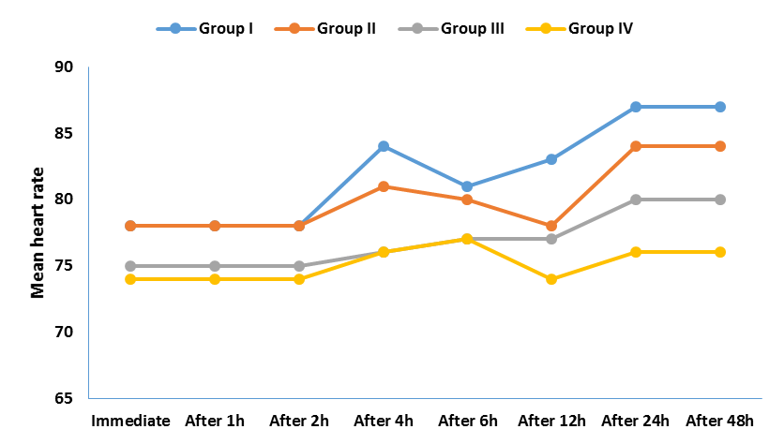
figure ( 21) Post-operative heart rate at different time points in different groups

- Post-operative Mean blood pressurein study groups
- Immediate post op, after 1 hour and after 2 hours
- There was an overall significant differencebetween study groups. P value <0.001. Pairwise analysis revealed that:
- Mean MBP in group I was significantly higher (83) compared to group II (80).
- Mean MBP in group I was significantly higher (83) compared to group III (80).
- Mean MBP in group I was significantly higher (83) compared to group IV (74).
- Mean MBP in group II was significantly higher (80) compared to group IV (74).
- Mean MBP in group III was significantly higher (80) compared to group IV (74).
- At 4 hours
- There was an overall significant differencebetween study groups. P value <0.001. Pairwise analysis revealed that:
- Mean MBP in group I was significantly higher (89) compared to group II (82).
- Mean MBP in group I was significantly higher (89) compared to group III (80).
- Mean MBP in group I was significantly higher (89) compared to group IV (78).
- Mean MBP in group II was significantly higher (82) compared to group IV (78).
- At 6 hours
- There was an overall significant differencebetween study groups. P value <0.001. Pairwise analysis revealed that:
- Mean MBP in group I was significantly higher (91) compared to group II (81).
- Mean MBP in group I was significantly higher (91) compared to group III (79).
- Mean MBP in group I was significantly higher (91) compared to group IV (75).
- Mean MBP in group II was significantly higher (81) compared to group IV (75).
- Mean MBP in group III was significantly higher (79) compared to group IV (75).
- At 12 hours
- There was an overall significant differencebetween study groups. P value <0.001. Pairwise analysis revealed that:
- Mean MBP in group I was significantly higher (85) compared to group II (82).
- Mean MBP in group I was significantly higher (85) compared to group III (81).
- Mean MBP in group I was significantly higher (85) compared to group IV (75).
- Mean MBP in group II was significantly higher (82) compared to group IV (75).
- Mean MBP in group III was significantly higher (81) compared to group IV (75).
- At 24& 48 hours
- There was an overall significant differencebetween study groups. P value <0.001. Pairwise analysis revealed that:
- Mean MBP in group I was significantly higher (90) compared to group II (82).
- Mean MBP in group I was significantly higher (90) compared to group III (83).
- Mean MBP in group I was significantly higher (90) compared to group IV (77).
- Mean MBP in group II was significantly higher (82) compared to group IV (77).
- Mean MBP in group III was significantly higher (83) compared to group IV (77).
(Table4& Figure22)

Table (4 ) Post-operative mean blood pressure in different study groups
 |  | Group I  (n = 30) |  | Group II  (n = 30) |  | Group III  (n = 30) |  | Group IV  (n = 30) | P value
Immediate | Mean ±SD | 83 ±3 |  | 80 ±3 |  | 80 ±2 |  | 74 ±3 | <0.001
After 1h | Mean ±SD | 83 ±3 |  | 80 ±3 |  | 80 ±2 |  | 74 ±3 | <0.001
After 2h | Mean ±SD | 83 ±3 |  | 80 ±3 |  | 80 ±2 |  | 74 ±3 | <0.001
After 4h | Mean ±SD | 89 ±5 |  | 82 ±3 |  | 80 ±3 |  | 78 ±3 | <0.001
After 6h | Mean ±SD | 91 ±5 |  | 81 ±3 |  | 79 ±3 |  | 75 ±3 | <0.001
After 12h | Mean ±SD | 85 ±3 |  | 82 ±3 |  | 81 ±3 |  | 75 ±3 | <0.001
After 24h | Mean ±SD | 90 ±2 |  | 82 ±2 |  | 83 ±2 |  | 77 ±2 | <0.001
After 48h | Mean ±SD | 90 ±2 |  | 82 ±2 |  | 83 ±2 |  | 77 ±2 | <0.001
One way ANOVA was used
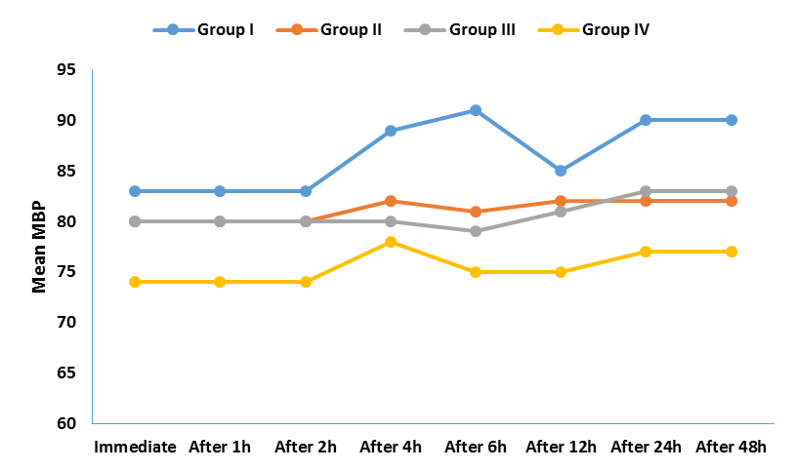
figure (22) Post-operative MBP at different time points in different groups

- Post-operative Visual Analogue Score (VAS)in study groups
- At 1 hour
- There was an overall significant differencebetween study groups. P value <0.001. Pairwise analysis revealed that Median VAS score in group I was 1 and ranged from 1 to 2 and this was significantly different from group II, III and IV as VAS in these groups was 1 in all patients.
- At 2 hours
- There was an overall significant differencebetween study groups. P value <0.001. Pairwise analysis revealed that Median VAS score in group I was 3 and ranged from 2 to 3 and this was significantly different from group II, III and IV as VAS in these groups was still 1 in all patients.

- At 4 hours
- There was an overall significant differencebetween study groups. P value <0.001. Pairwise analysis revealed that Median VAS score in group I was 2 and ranged from 2 to 3 and this was significantly different from group II, III and IV as VAS in these groups was still 1 in all patients.
- At 6 hours
- There was an overall significant differencebetween study groups. P value <0.001. Pairwise analysis revealed that Median VAS score in group I was 3 and ranged from 2 to 3 and this was significantly different from group II, III and IV as VAS in these groups was still 1 in all patients except for group II in which median VAS was 1 ranged from 1 to 2.
- At12 hours
- There was an overall significant differencebetween study groups. P value <0.001. Pairwise analysis revealed that Median VAS score in group I was 3 and ranged from 2 to 3 and this was significantly different from group II, III and IV as VAS in groups III and IV was still 1 in all patients and in group II median VAS was 2 and ranged from 1 to 3. Also median VAS in group II was significantly higher in group II (2) compared to groups III and IV (1).
- At 24 hours
- There was an overall significant differencebetween study groups. P value <0.001. Pairwise analysis revealed that Median VAS score in group I was 3 and ranged from 2 to 3 and this was significantly different from group III and IV as median VAS in groups III and IV was 1 in both groups and ranged from 1 to 2 in group III and from 1 to 3 in group IV. Also median VAS in group II was significantly higher in group II (2) compared to groups III and IV (1).
- At 48 hours
There was an overall significant differencebetween study groups. P value <0.001. Pairwise analysis revealed that Median VAS score in group I was 2 in all patients and this was significantly different from group II, III and IV as VAS in these groups was 1 in all patients.(Table5& Figur 23)

Table (5 ) Post-operative visual analogue scale in different study groups
 |  | Group I  (n = 30) |  | Group II  (n = 30) |  | Group III  (n = 30) |  | Group IV  (n = 30) | P value
At 1h | Median (range) | 1 (1 - 2) |  | 1 (1 - 1) |  | 1 (1 - 1) |  | 1 (1 - 1) | <0.001
At 2h | Median (range) | 3 (2 -3) |  | 1 (1 - 1) |  | 1 (1 - 1) |  | 1 (1 - 1) | <0.001
At 4h | Median (range) | 2 (2 - 3) |  | 1 (1 - 1) |  | 1 (1 - 1) |  | 1 (1 - 1) | <0.001
At 6h | Median (range) | 3 (2 - 3) |  | 1 (1 - 2) |  | 1 (1 - 1) |  | 1 (1 - 1) | <0.001
At 12h | Median (range) | 3 (2 - 3) |  | 2 (1 - 3) |  | 1 (1 - 1) |  | 1 (1 - 1) | <0.001
At 24h | Median (range) | 3 (2 - 3) |  | 2 (1 - 3) |  | 1 (1 -2) |  | 1 (1 -3) | <0.001
At 48h | Median (range) | 2 (2 -2) |  | 1 (1 - 1) |  | 1 (1 - 1) |  | 1 (1 - 1) | <0.001
Kruskal Wallis test was used
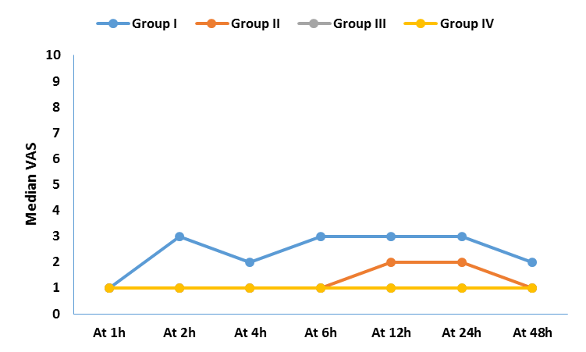
figure (23 ) Post-operative VAS at different time points in different groups

- Time to 1st analgesiain study groups
- There was an overall significant differencebetween study groups. P value <0.001. Pairwise analysis revealed that
- Mean time in group I was significantly lower (3 hours) compared to group II (12.4 hours), group III (18.5 hours) and group IV (34.1 hours)
- Mean time in group II was significantly lower (12.4) compared to group III (18.5 hours) and group IV (34.1 hours)
- Mean time in group III was significantly lower (18.5) compared to group IV (34.1 hours).
(Table6& Figure24)

Table (6 ) Time to 1st analgesia request in different study groups
 |  | Group I  (n = 30) | Group II  (n = 30) | Group III  (n = 30) | Group IV  (n = 30) | P value
Time to 1st analgesia | Mean ±SD | 3 ±0.7 | 12.4 ±1.6 | 18.5 ±1.5 | 34.1 ±4.3 | <0.001
One way ANOVA was used

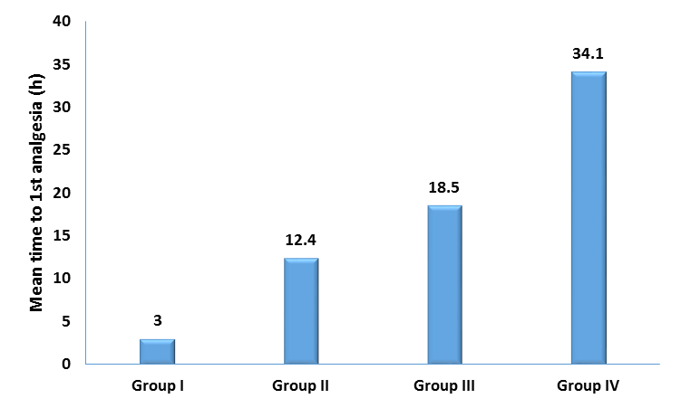
figure (24 ) Time to 1st analgesia request in different groups

- Total morphine consumption
- There was an overall significant differencebetween study groups. P value <0.001. Pairwise analysis revealed that:
- Mean consumption in group I was significantly higher (20) compared to group II (14), group III (10) and group IV (5)
- Mean consumption in group II was significantly higher (14) compared to group III (10) and group IV (5)
Mean consumption in group III was significantly higher (10) compared to group IV (5) (Table7& Figure25)

Table ( 7) Total morphine consumption in different study groups
 |  | Group I  (n = 30) | Group II  (n = 30) | Group III  (n = 30) | Group IV  (n = 30) | P value
Total morphine consumption | Mean ±SD | 20 ±2 | 14 ±4 | 10 ±3 | 5 ±1 | <0.001
One way ANOVA was used

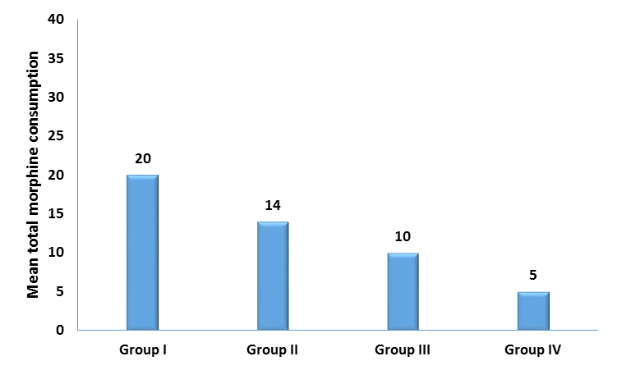
figure ( 25) Total morphine consumption in different groups

- Complications and nausea & vomiting
- There were no significant differences between study groups as regard nausea &vomiting.
- No complications or psychological complications were reported in all groups.(Table8& Figure30)

Table (8 ) Frequency distribution of complications and nausea&vomiting in different study groups
 |  | Group I  (n = 30) | Group II  (n = 30) | Group III  (n = 30) | Group IV  (n = 30) | P value
Complications | Yes n (%) | 0 (0.0) | 0 (0.0) | 0 (0.0) | 0 (0.0) | -
Nausea | Yes n (%) | 9 (30.0) | 4 (13.3) | 2 (6.7) | 2 (6.7) | 0.05
Vomiting | Yes n (%) | 4 (13.3) | 2 (6.7) | 0 (0.0) | 0 (0.0) | 0.054
Psychological complications | Yes n (%) | 0 (0.0) | 0 (0.0) | 0 (0.0) | 0 (0.0) | -
Fisher's exact test was used

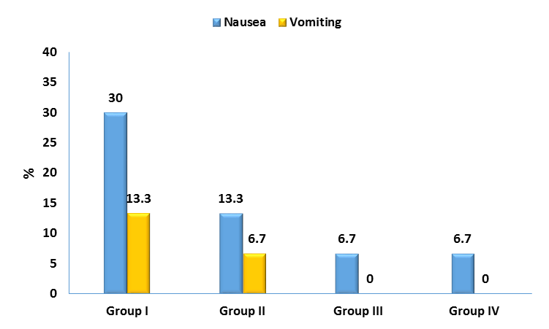
Figure(26) ) Frequency distribution of complications and nausea&vomiting in different study groups

- Patient satisfaction
- There was an overall significant difference between study groups. P value <0.001. Pairwise analysis revealed that satisfaction in group I was significantly different from all groups. Only 3.3% reported excellent satisfaction in group I compared to 33.3% in group II, 66.7% in group III and 100% in group VI. Also satisfaction in group II was significantly different form groups III and IV and group III was significantly different from group IV.(Table9) Figure(31)

Table (9 ) Patient satisfaction in different study groups
 |  | Group I  (n = 30) |  | Group II  (n = 30) |  | Group III  (n = 30) |  | Group IV  (n = 30) | P value
Satisfaction | Excellent n (%) | 1 (3.3) |  | 10 (33.3) |  | 20 (66.7) |  | 30 (100.0) | <0.001
 | Fair n (%) | 18 (60.0) |  | 4 (13.3) |  | 0 (0.0) |  | 0 (0.0)
 | Good n (%) | 5 (16.7) |  | 16 (53.3) |  | 10 (33.3) |  | 0 (0.0)
 | Poor n (%) | 6 (20.0) |  | 0 (0.0) |  | 0 (0.0) |  | 0 (0.0)
Chi-square test was used

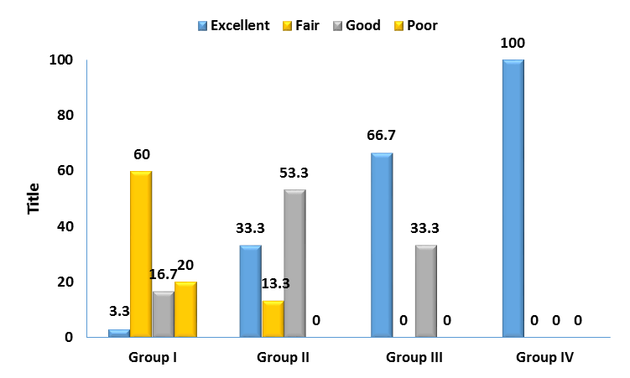
figure (27) Patient satisfaction grades in different groups

Statistical methods
Data management and statistical analysis were done using SPSS vs.25. (IBM, Armonk, New York, United states).
Numerical data was summarized as means and standard deviations or medians and ranges. Categorical data was summarized as numbers and percentages.
Comparisons between four groups were done using one way ANOVA or Kruskal Wallis test for normally and non-normally distributed numerical variables. Categorical data was compared using Chi-square test or Fisher's exact test when appropriate. Pairwise comparisons were done in case of overall significance and all pairwise comparisons were adjusted for multiple comparisons.
All P values were two sided. P values less than 0.05 were considered significant.

